Course Name: CMPE187/287 -01 - Software Quality Testing

Instructor: Dr. Jerry Gao
Homework #3:
Instructors: Jerry Gao, Ph.D.
Semester: Spring, 2023
Posted date: 10/26/2023 Due date: 10/26/2023

Question #1: Software Integration Testing (25%)

- (20%) Questions about software integration based on a program structure shown in Figure 1:
- Explain the idea of the top-down integration approach. (3%)
- List an integration sequence using the top-down approach and its required test stubs (or drivers) using the breath-first order. (5%)
- List the required total number of test stubs. (5%)
- Explain the idea of the bottom-up integration approach. (2%)
- List an integration sequence using the bottom-up approach and its required test drivers. (5%)
- List the required total number of test drivers. (5%)

Hints: Please writes your integration sequence as follows:
A
- Integrated system (IS) = module A and module B (required test stubs for C,D and E)
E
- Integrated system (IS) = IS and module D
B
C
……….
D

M3
M2
M13

M1

M4
M5
M7
M6

M10
M9
M12
M11
M8
Figure 1.

Question #2: Questions about Software Regression Testing (40%)

Figure 2 shows the class relation structure among the classes of a program written in C++. “I” indicates an Inheritance relation between two classes. “AG” represents an aggregation relation between two class objects, “AS” indicates an association relation between two classes. Assume Class 7 and Class 1 are changed. Please follow the class firewall’s concept to identify a class firewall to enclose all affected classes and re-integration links after changing Class 7 and Class 1. (Note: pleased Please present this class firewall by answering the following questions:
- (10%) What is the class test order based on the class diagram in Figure 2.
- (10%) What are the class firewalls for the two changed classes, and please present the two firewalls separately using a diagram.
- (10%) Which classes are not directly affected by each changed class, but must be re-integrated?
- (10%) Please list the class re-test order for each detected class firewall.

You may need to read the published papers below:

Paper 1: Class Firewall, Test Order, and Regression Testing of Object-Oriented Programs, Journal of Object-Oriented Programming, 1993.
by David C. Kung, Jerry Gao , Pei Hsia , Jeremy Lin , Yasufumi Toyoshima

URL: http://citeseerx.ist.psu.edu/viewdoc/summary?doi=10.1.1.53.6284

Paper 2: A Test Strategy for Object-Oriented Programs
By D. Kung ; J. Gao ; Pei Hsia ; Y. Toyoshima ; C. Chen,
Proceedings., Nineteenth Annual International conference on Computer Software and Applications, 1995. (COMPSAC 95)

URL: http://ieeexplore.ieee.org/abstract/document/524786/

Paper 3: Change Impact Identification in Object-Oriented Software Maintenance
By D. Kung, J. Gao, P. Hsia, F. Wen, Y. Toyoshima, Ray Chen
URL: http://ieeexplore.ieee.org/abstract/document/336774/

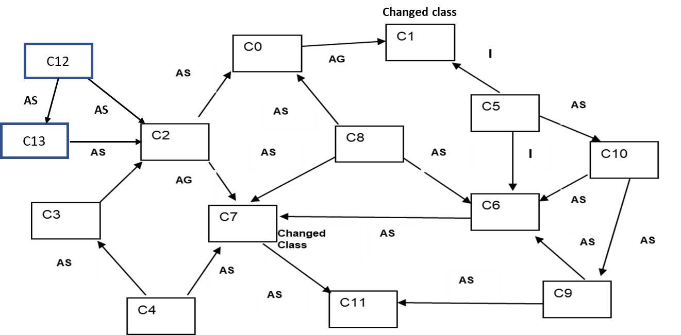

Figure 2.

Question #3: Testing a selected AI Mobile App (35%)

For your selected intelligent function/feature of your mobile app (or online app), please focus on one of your selected AI-powered function and conduct your 3D AI test modeling based on our lecture and given 3D AI test tool.

Please answer the following questions:

- Your 3D AI test modeling test model: (20%)
  - Context Model (Context Modeling Tree) (5%)
  - Input Classification Model (Input Classification Tree) (5%)
  - Output Classification Model (Output Classification Tree) (5%)
  - 3D Decision Table (10%)
- Your test complexity based on your 3D AI decision table (5%)
- Present three your selected bugs you detected. (5%)
Please present your bugs in a well-defined format.

